[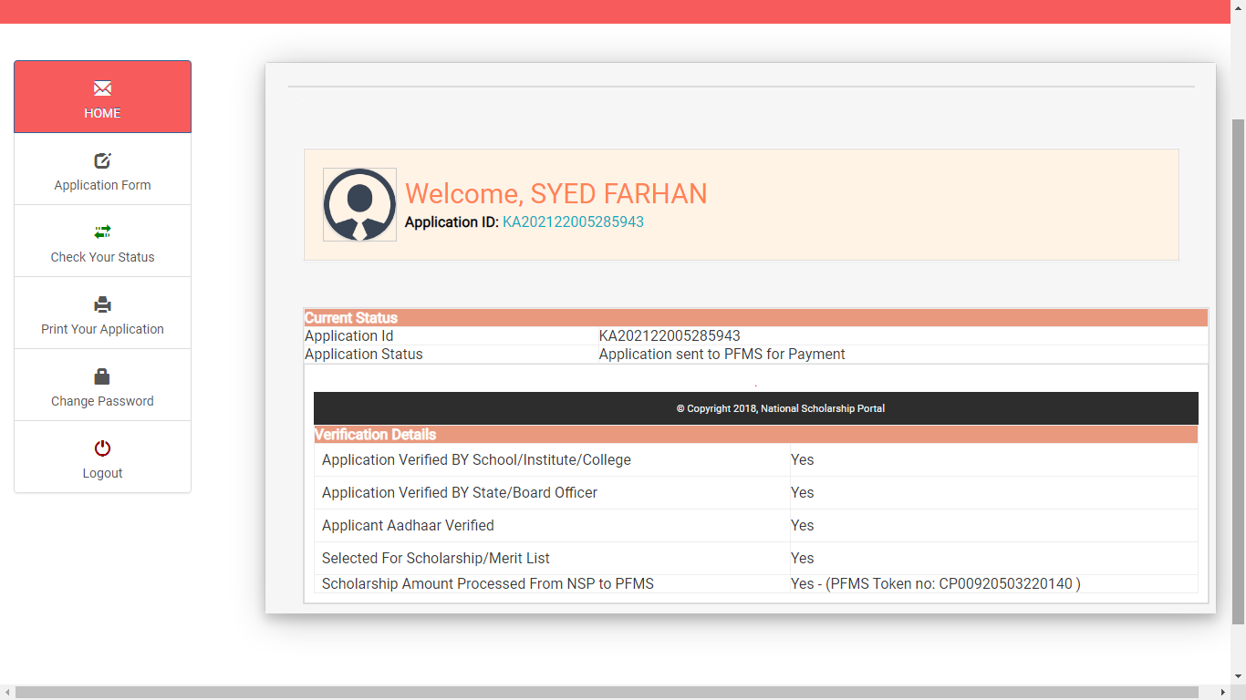](mailto:syedrihan223@gmail.com?subject=NSP)